MM Lite Infrastructure Scenarios

Table 1 Change History
Ed | Date | Description | Changes made by
0.1 | 10-Oct-2011 | Initial draft | Aradhana Palat
0.2 | 05-Dec-2011 | Added IPT scenarios | Aradhana Palat
0.3 | 12-Dec-2011 | Updates / corrections to IPT scenarios  Refer to “SPC E”  Updates to roadside cabinets: added CEC and 609.  More details (in the diagrams and text boxes) to nature of Solo deployments allowed | Aradhana Palat
0.4 | 14-Dec-2011 | Added new scenario: Resilient chain of Solos between SASM and SASD | Aradhana Palat
1.0 | 05-Jan-2012 | - First External Release  - Removed IF scenario with chain of Solos between SASM and SASD in version 0.4  - Revised version numbering scheme | Aradhana Palat
1.1 | 25-Jan-2012 | Updated scenarios for IPT over MM Lite via SASD and SASM to also show TS at far end for clarity  Added new scenario for adjacent minor TSs – local redundant 10 GE link via end SASMs  New scenarios: IPT directly attached to SASD and SASM in both 2 GE and 10 GE redundant link scenarios  Renaming of all key scenarios for clarity following addition of new scenarios. | Aradhana Palat
1.2 | 02-Feb-2012 | Updates following review with Fluor /HA.  - Show bypassed TSs  - Show “end SASM” inside the TS.  - Updates to several text boxes  - Show complete service path in IPT scenarios  - Removed constraints; number of SASDs in a cabinet, number of Solos in a cabinet. | Aradhana Palat
1.3 | 07-Mar-2012 | Section 2: Show one end SASM outside the TS as an example that the scheme can extend beyond TSs providing core network connectivity. | Aradhana Palat

Table of Contents
1 Introduction 4
2 MM Lite scheme with local10 GE redundant path 5
3 MM Lite schemes with redundant paths via the core network 6
3.1 MM Lite Scheme between adjacent minor TSs 6
3.2 MM Lite Scheme between two adjacent TSs, one minor and one major: 7
3.3 MM Lite Scheme terminating outside a TS, connecting to core network via a minor TS 8
3.4 MM Lite scheme terminating outside a TS, connecting to core network via major TS 9
4 Solo Deployment Scenarios 10
5 IPT within MM Lite 11
5.1 IPT device attached to an MM Lite SASM 11
5.2 IPT device attached to an MM Lite SASD 12
5.3 IPT over 8RMD via an MM Lite SASM 13
5.4 IPT over 8RMD via an MM Lite SASD 14
6 MM Lite Scheme bridging 1423 chains 15

Introduction
This document describes the MM Lite Infrastructure scenarios.

This document is version controlled in docushare at the link below:
http://docushare.web.alcatel-lucent.com/dsweb/View/Collection-679999

MM Lite scheme with local10 GE redundant path
Bypassed TSs i.e. no access to core network from these TSs
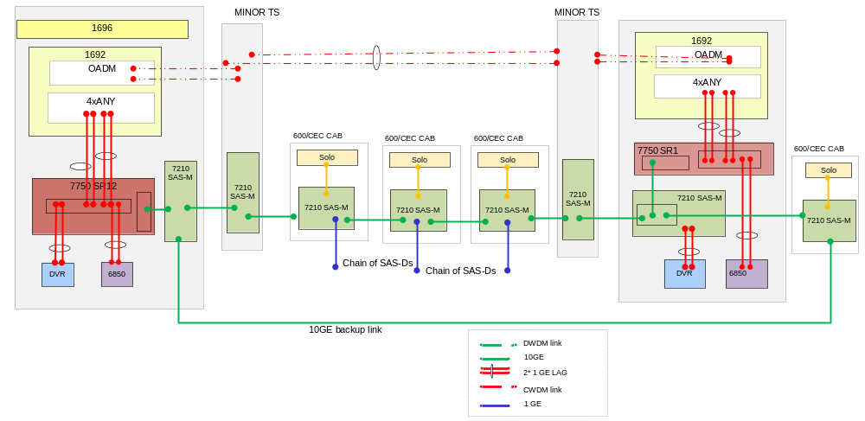
If the 10 GE backup link terminates at a SASM in a major or minor TS providing core network access, a total of three 10 GE ports will be required, one to connect to the SR1/SR12, one to connect to the chain of SASMs, and one to connect to the backup link. An additional MDA will need to be installed in the SAS-M expansion slot to accommodate the 10 GE backup link. If the SASM chain continues beyond a TS providing core network access, then third 10 GE port is still required in the TS to connect to the next SASM
If both available MDAs are already in use on the SR1 for 1 GE services, one of the MDAs will be replaced by a 10 GE MDA.
1 GE services offered via the MDA that is replaced will need to be ported from the SR-1 to the SAS-M

MM Lite schemes with redundant paths via the core network

MM Lite Scheme between adjacent minor TSs
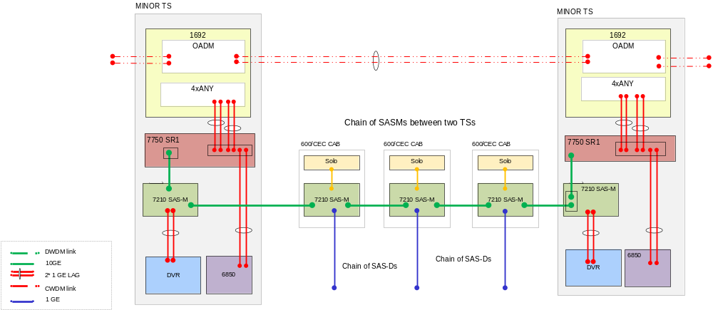

At the Minor TSs, if both available MDAs are already in use on the SR1 for 1 GE services, one of the MDAs will be replaced by a 10 GE MDA. The services on the replaced 1 GE MDA will be offered via 1 GE ports on the SASM.

MM Lite Scheme between two adjacent TSs, one minor and one major:
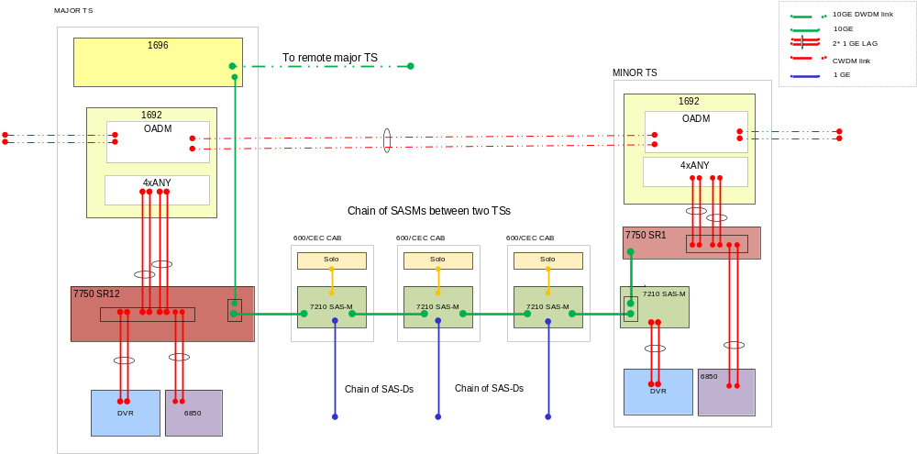
Additional IOM cards and 10GE MDAs may be required in the 7750 SR-12 depending on the existing configuration and the number of new connections.

MM Lite Scheme terminating outside a TS, connecting to core network via a minor TS
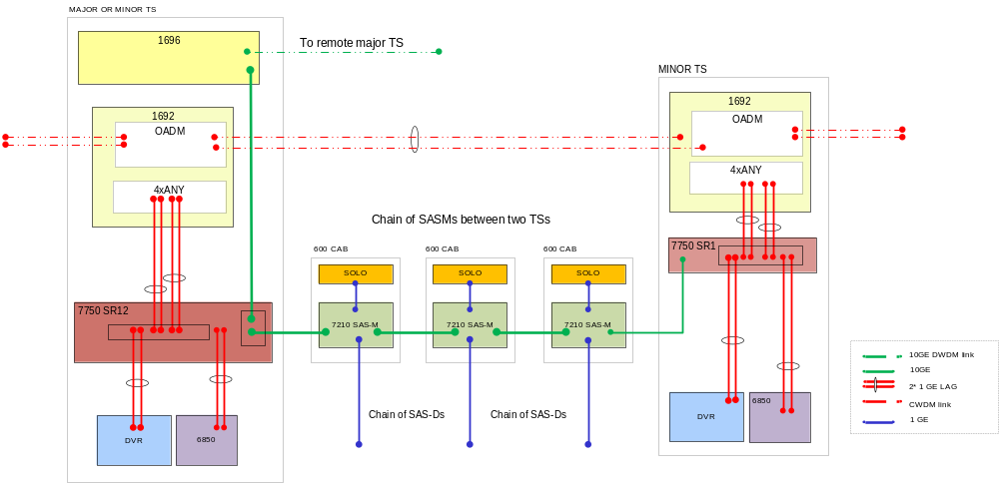
No SASM at the minor TS

MM Lite scheme terminating outside a TS, connecting to core network via major TS

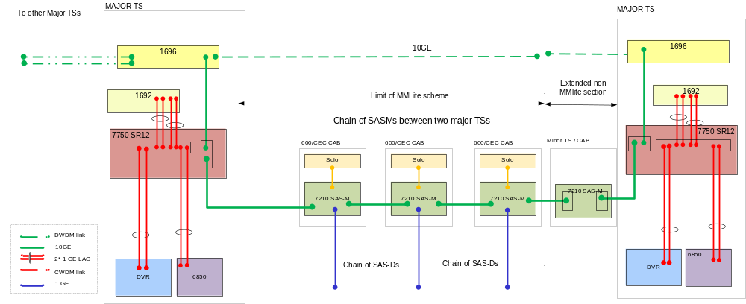
Additional IOM cards and 10Gb MDAs may be required in the 7750 SR-12 depending on the existing configuration and the number of new connections.
Intermediate minor TSs may be bypassed to reach the major TS.

Solo Deployment Scenarios

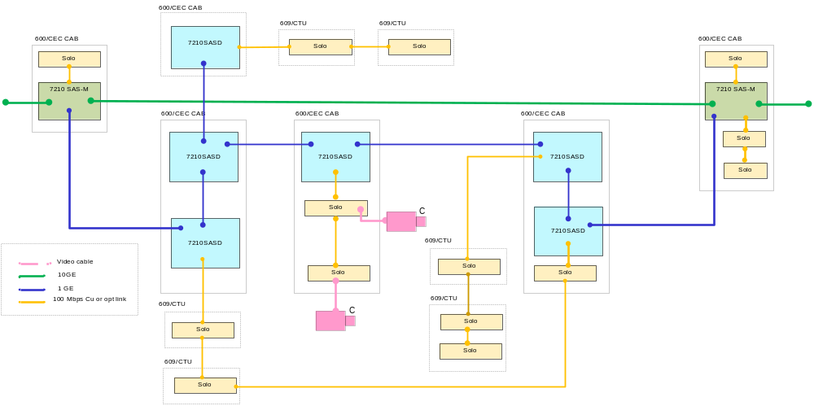
Solo deployments
- Any one SAS-D can only support one SOLO chain.
- Maximum one resilient chain of Solos between two SASDs
- A resilient chain can exist only between two SASDs in the same SASM chain.
- SOLO chains are not allowed between a SAS-D and its subtended SAS-Ds.
- A non-resilient chain of maximum four Solos subtended from a single SASM service port.
- A Solo may also be housed in a CTU at the base of a camera mast.
SASD deployments
- Ring of up to 6 SASDs between two SASMs.
- A maximum of three SASDs in a chain may have a subtended SASD, making a total of nine SASDs between two SASMs.
- Maximum four SASD rings terminate at a SASM.

IPT within MM Lite

IPT device attached to an MM Lite SASM
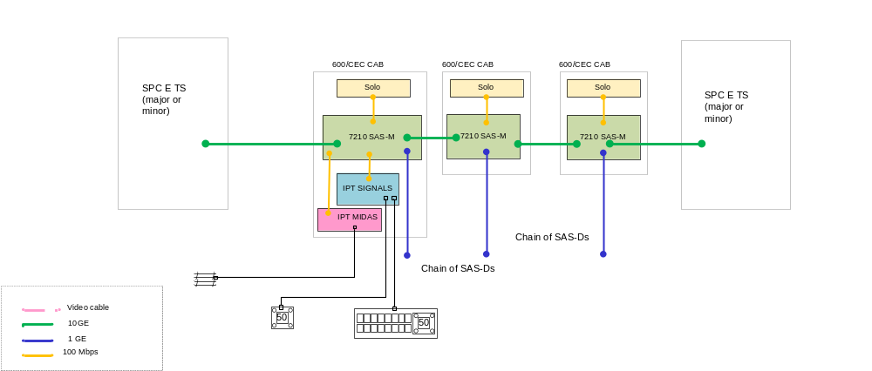

IPT device attached to an MM Lite SASD
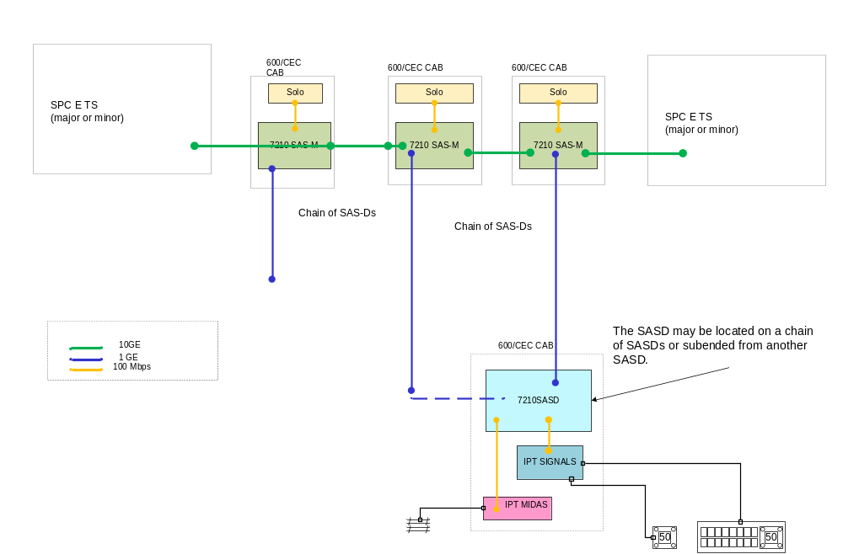

IPT over 8RMD via an MM Lite SASM
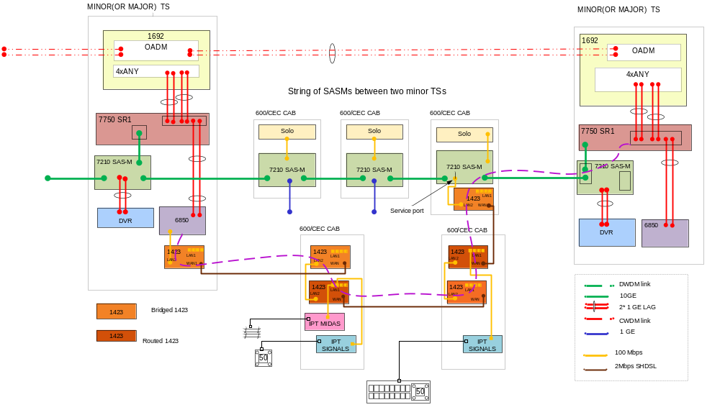
1423 LAN_1 ports 1-3 only are available for service delivery
The service path towards the TS on the left is via the 1423 chain.
The service path towards the TS on the right is via the SASM.

IPT over 8RMD via an MM Lite SASD
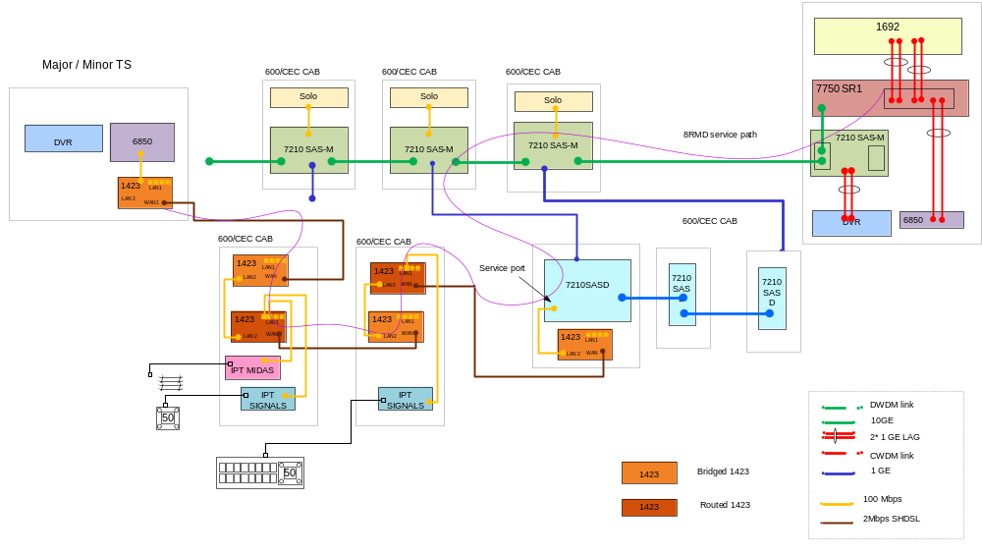
1423 LAN_1 ports 1-3 only are available for service delivery
The service path towards the TS on the left is via the 1423 chain.
The service path towards the TS on the right is via the SASM.

MM Lite Scheme bridging 1423 chains
